How did we create the knut knut model?
First, we started printing the data by the 4 different routes:
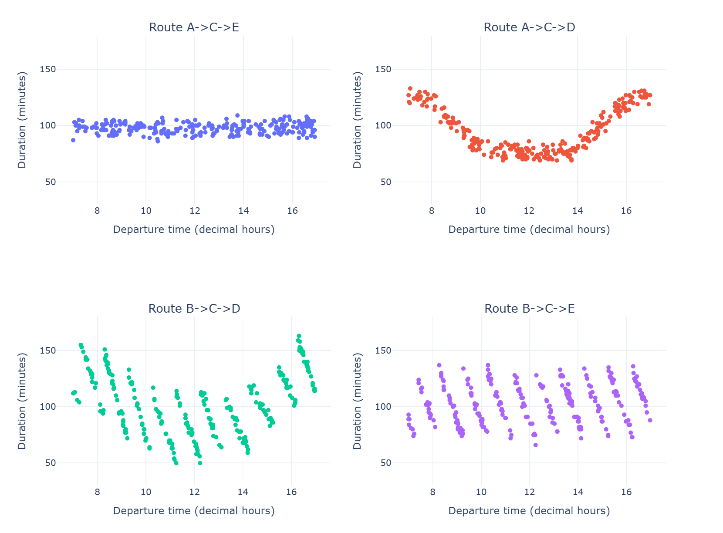
We found out that the routes followed a well-defined patter, so we just tried to found it which equation defines the duration of every route.
- For the first route A-C-E we did a linear regression with all the data.
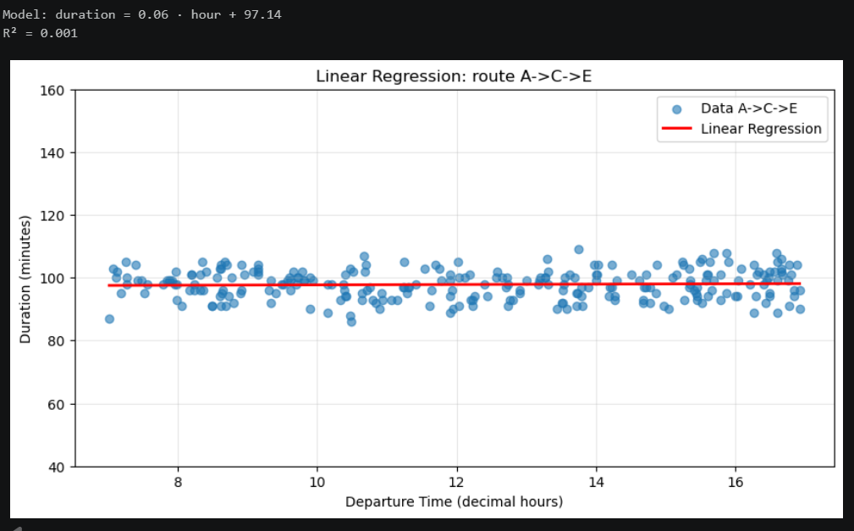
And we found out that the duration of the route was basically around 98 minutes

- For the second route A-C-D we think about equations to fit the data, and we found that a sum of sigmoid worked perfect and simple:
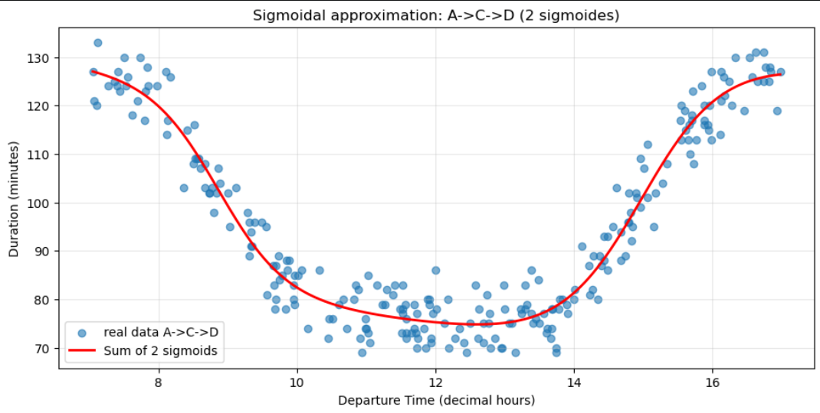
And we found out this ecuation
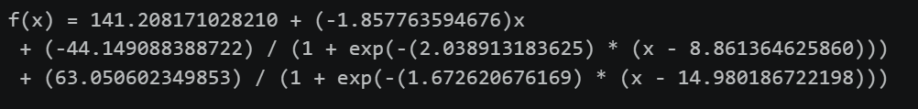
Only between 7 and 17 hours.

- For the last two routes B-C-D and B-C-E, we divided the data into time slots because as we can see in the plot the data is very well defined.
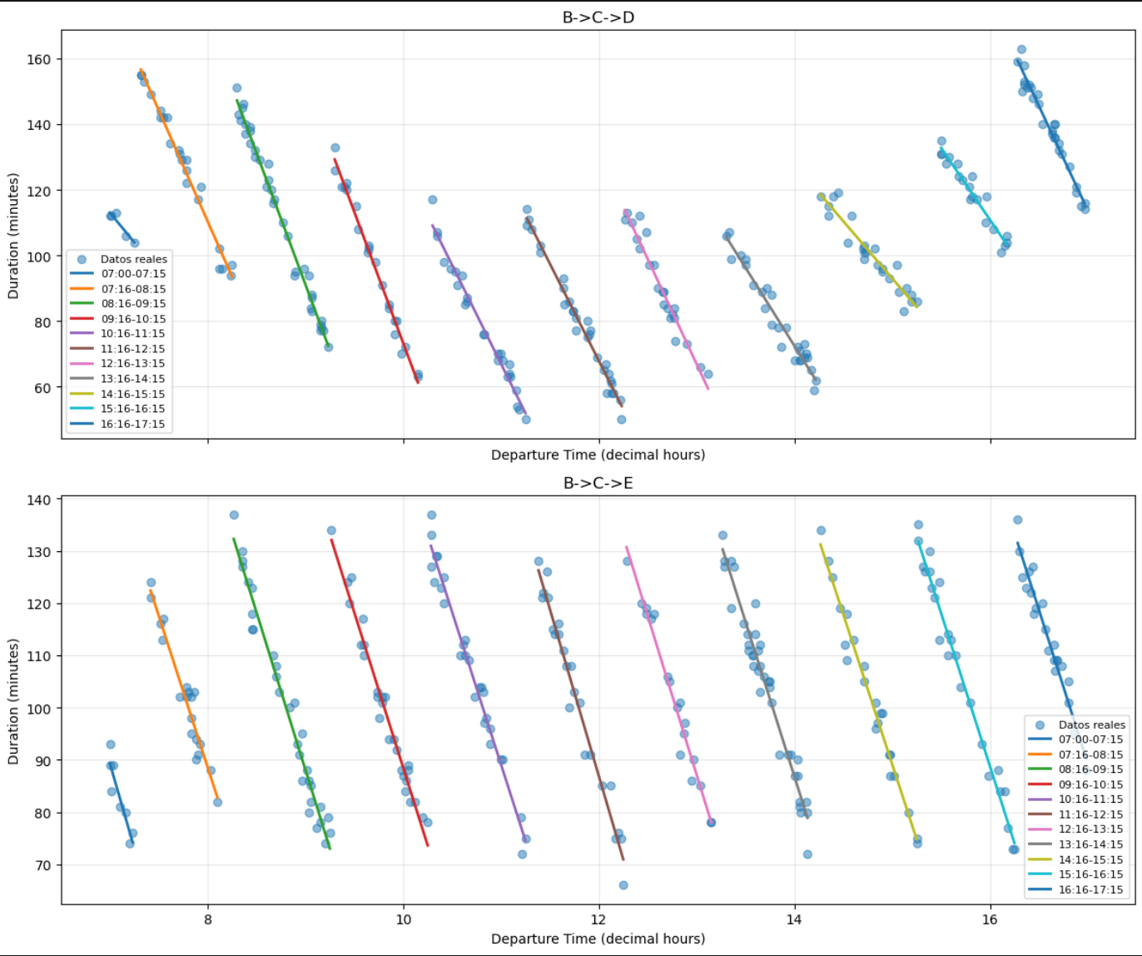
So we found an equation for each time slot using linear regression.
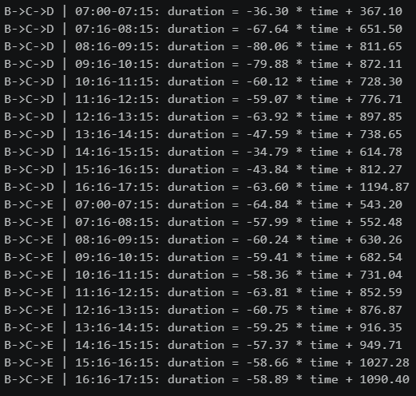
And with all 4 equations one for each route, we can predict the quickest route and how much time we save from other routes.

